# Laboratory 3

## Requirements

The requirement is to optimize the Performance of the cloud infrastructure that was created using VMware Hypervisor ESXi in the previous laboratory. The aim is to improve either the execution time or resource utilization. The optimization can be done at code, hypervisor or OS level.

# Experiment Design

## Machine Configuration

For this Laboratory work below are my test lab configuration;

1. Laptop:
   1. Model name: MacBook Pro
   2. Processor: Intel Core i7 2.8 Ghz
   3. Number of processors: 1
   4. Number of Cores: 4
   5. Memory: 16 GB
2. Hypervisor
   1. VMware Fusion 10.0.1
   2. VMWare ESXi 6.5: 2 CPU and 4GB
3. VM OS used
   1. Ubuntu 16.04 LTS 32 bits
   2. Ubuntu 16.04 LTS 64 bits
   3. Fedora 27 64 bits

## Code to be Used

For this lab purposes, I am using smuprogram1a.c. For further experiment purpose, I also tried smuprogram3a.c, smuprogram3b.c and smuprogram3c.c in last configuration.

## Optimization Used

The optimization is used for this Lab work are;

1. HV-02: Change from 32 to a 64-bit installation
2. HV-01: Increase memory allocation or disk allocation to a virtual machine where the code will operate
3. HV-05: Run two concurrent VMs executing maximum usage code and then only one, see if there is a difference
4. HV-06: Increase the CPU cores (using CPU Hot Add supported for Ubuntu but not Fedora) (Own change)
5. CO-05: Using inline-function to improve performance of smuprogram1a.c
6. CO-01: Change code instructions to increase spatial locality (data that may have been read into buffer as a cache system read)

I selected these optimization dues to the High execution time and CPU utilization I saw when I executed the smuprogram1a.c. The optimization was to fine tune my cloud infrastructure first followed by code optimization.

# EXECUTION

For this laboratory purposes, I named each change as a configuration.



## Configuration 1: Baseline Results (32 bit 1 core and 1GB RAM)

For the baseline, I started the lab with a single CPU core and one Core per socket. The OS used was Ubuntu 32 bits on 1 GB RAM with 15 GB Hard Disk allocated.

When I executed program, I observed following which was used as baseline.

1. It took 1 min and 17 secs to execute the smuprogram1a.c (Appendix 1)
2. When the Program was being executed for the entire duration the Overall CPU utilization for the VM was 100% and overall CPU utilization for hypervisor was over 50% (Appendix 2)



## Configuration 2: 32 bits with 2 cores and 2 GB RAM

For this configuration, I used HV-02 to add additional memory defined and mine own change (which I named as HV-06) of adding additional CPU to my VM. Final Configuration for the VM was

1. 2 CPU, 1 Core per socket (Sockets total 2)
   1. Limit unlimited, No reservation and Normal share
2. 2048 RAM
   1. Limit unlimited, No reservation and Normal share
3. 15 GB hard Disk



The observation with this configuration was not significant. On one side, I saw overall CPU utilization improved for the VM by 50% but on same I saw the response time for total execution increased by 3 secs (increase of 4 %) (Appendix 3). The response time increase could be due to CPU switching that I am seeing during the execution. The Overall CPU utilization was improved by 50% because one Core was used 100% while second core was open for other processes (Appendix 4).

## Configuration 3: 64 bits with 1 core and 1 GB RAM

For this configuration, I updated my OS from a 32 bit to 64 bits compared to “Configuration 1”. With the change, I immediately see a significant improvement in Response time for the program execution. **The response time for the execution improved from 77 secs to 40 secs (Appendix 6). This was an improvement of 48%.**

The CPU was still spiking to 100% (Appendix 7) but since execution time was less the spike was low.



## Configuration 4: 64 bits with 2 cores and 1 GB RAM

Since the code execution was still taking 100% of CPU utilization the VM was not able to process other requests as quickly. Based on configuration 2 I decided to add one more core to the VM so that overall CPU utilization can reduce and other process also get equal processing power. The memory was not increased because based on current usage of the VM the memory allocated for the VM (1 GB) was enough with Swap space helping the VM to work efficiently.

However, there was a negative impact of 1.09 sec (Appendix 8) seen and this was due to CPU switching for the process. CPU utilization did improve with this configuration (Appendix 9)



## Comparison for configuration 1 vs configuration 2 vs configuration 3 vs configuration4

Based on above 4 labs test I concluded that the best configuration is;

1. 64 bits OS
2. Dual Core
3. 1 GB RAM
4. 20 GB Hard Disk

**The final configuration helped the response time improved from 77 secs to 40 sec and overall CPU utilization improved by 50% for VM and 33 % for hypervisor.**

## Configuration 5: Optimizing the Code for smuprogram1a.c

For this configuration, I went through the code and decided to do following code optimizations:

1. CO-05: Used inline-function to improve performance of smuprogram1a.c
2. CO-01: Change code instructions to increase spatial locality (data that may have been read into buffer as a cache system read)

With the original code the response time I saw was 42 secs (appendix 10) and after the optimization the response time improved by 9 secs (21 %) and executed in 33 secs (appendix 11). This also mean a quick recovery of CPU for other process.

## Configuration 6: Two VM running the code smuprogam1a.c simultaneously

For this configuration, I expanded my VM pool to add an additional VM running Fedroa 64-bit OS and same configuration as Ubuntu machine running 64-bit OS. Each machine had 2 cores and 1 GB RAM. Both of them were allocated 20GB disk space.

When I executed the original program smuprogram1a.c I observed that the response time for program execution increased from 33 secs to 55 secs (appendix 12). The CPU utilization also increases as now all the cores were working (appendix 13).

## Configuration 7: Two VM running the optimized code smuprogam1a.c simultaneously

For this configuration, I took the same configuration as “Configuration 6” and the optimized code from “Configuration 5”.

When I executed the optimized program smuprogram1a.c I observed that the response time for program execution improved and was back to 44 secs and 46 secs (appendix 14). The CPU utilization also improved significantly due to improvement in response time (appendix 15).

# Final Configuration comparison

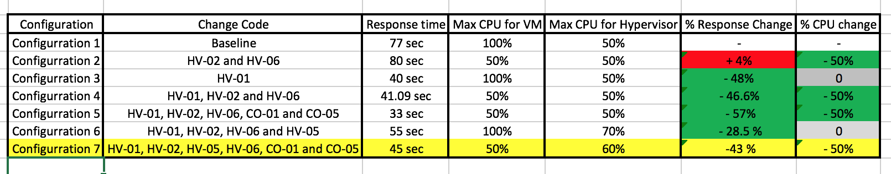

# Appendix

## Appendix 1: Execution time for configuration 1



## Appendix 2: CPU utilization for configuration 1

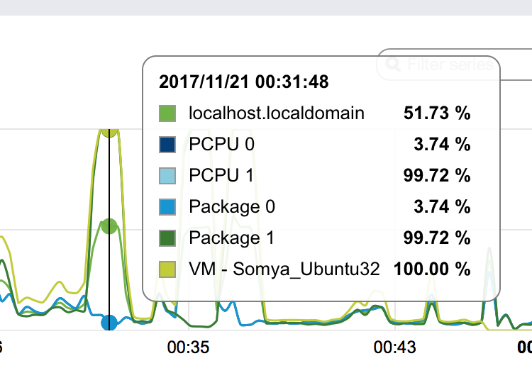

## Appendix 3: Execution time for configuration 2



## Appendix 4: CPU utilization for configuration 2

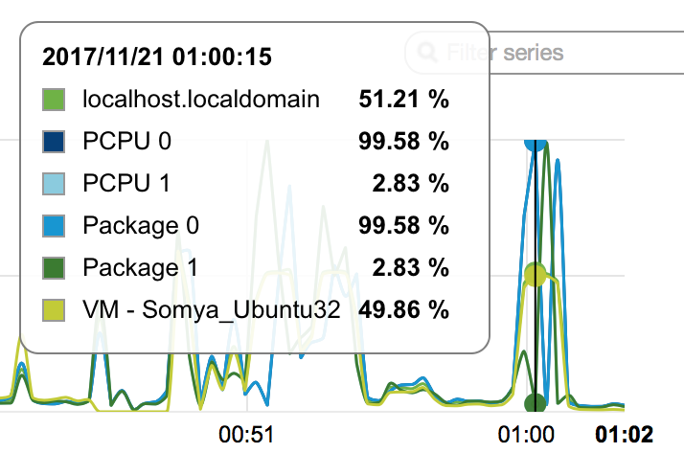

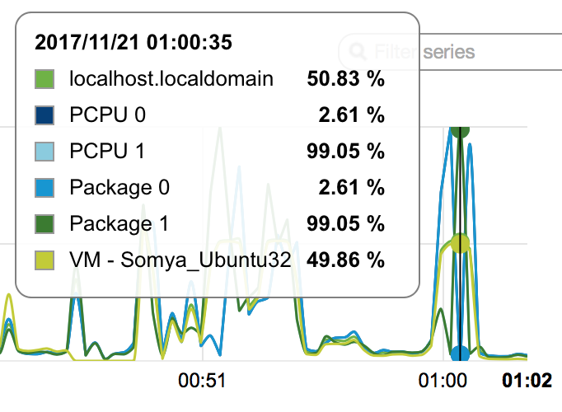

## Appendix 5: CPU utilization for configuration 1 vs 2



## Appendix 6: Execution time for configuration 3

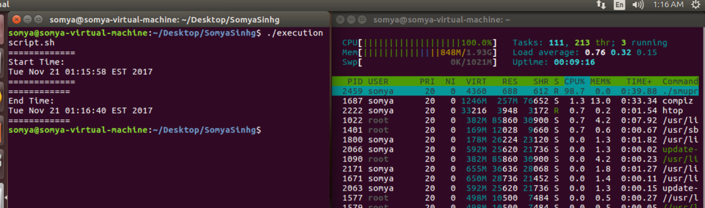

## Appendix 7: CPU Utilization for configuration 3

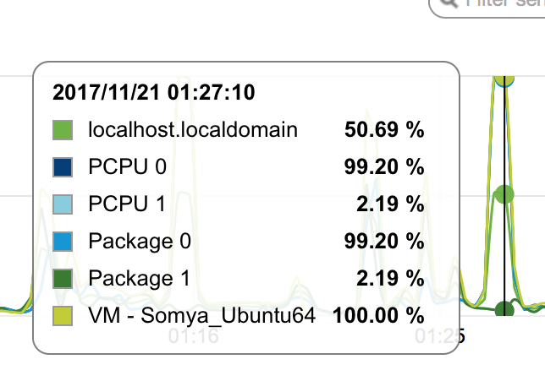

## Appendix 8: Execution time for configuration 4

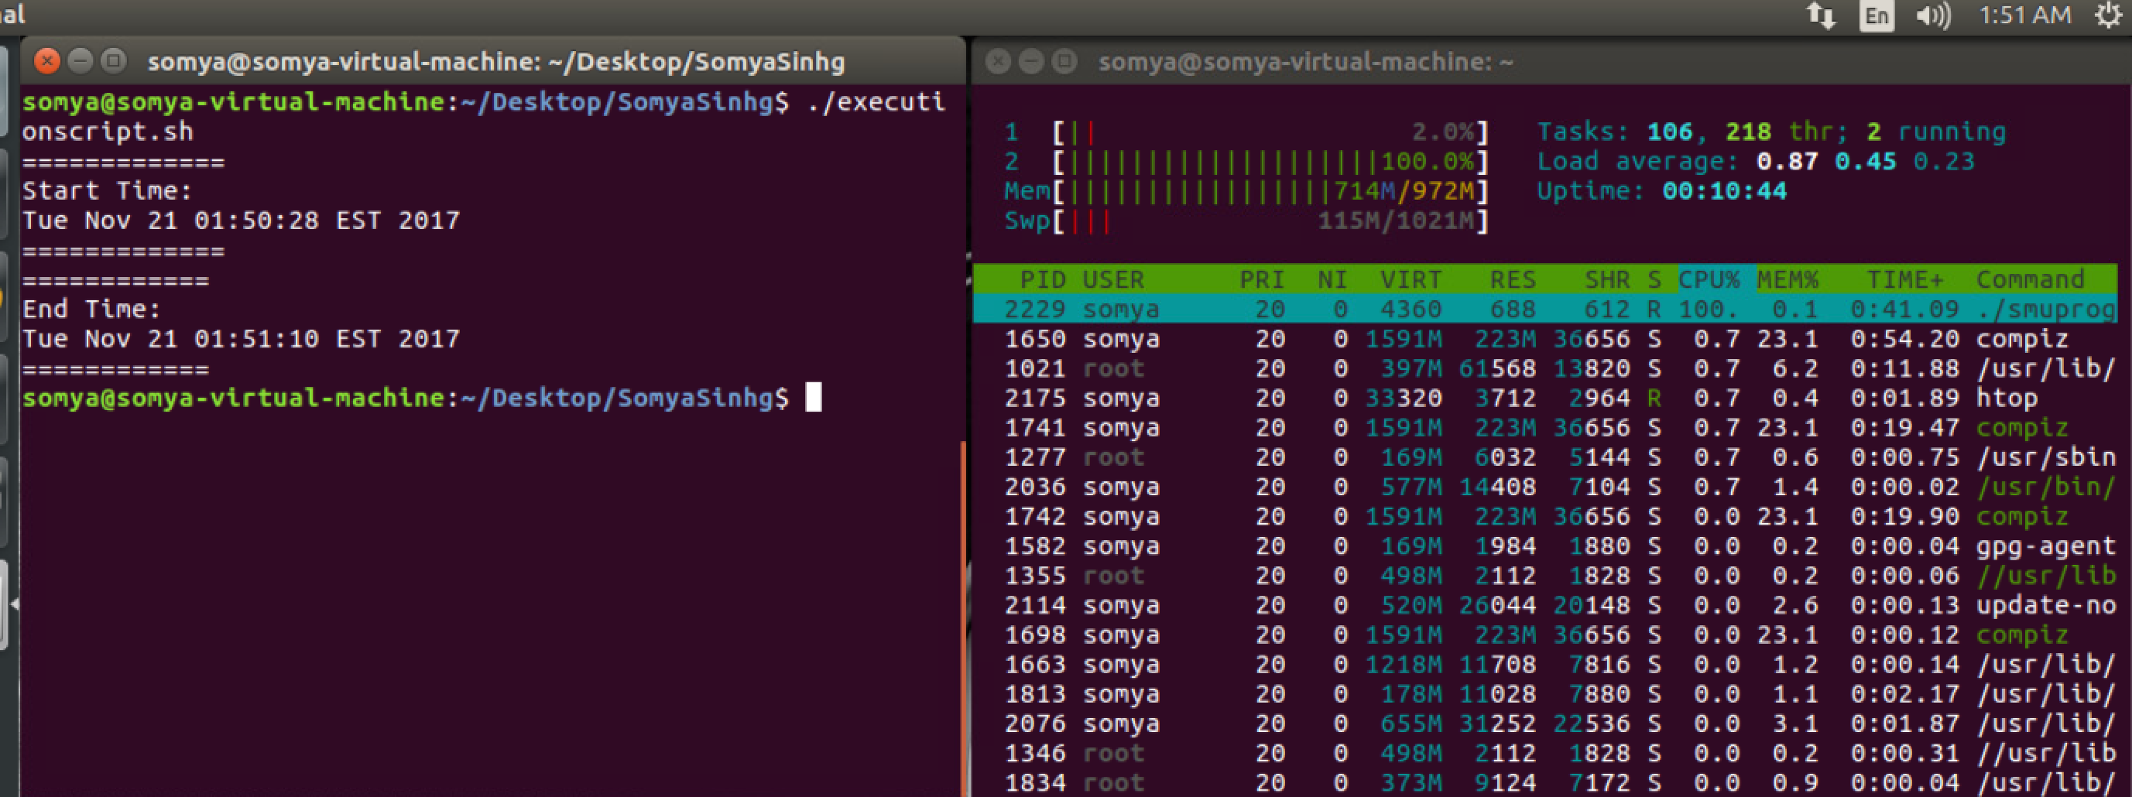

## Appendix 9: CPU Utilization for configuration 4



## Appendix 10: CPU Utilization and execution time for configuration 5 with original code



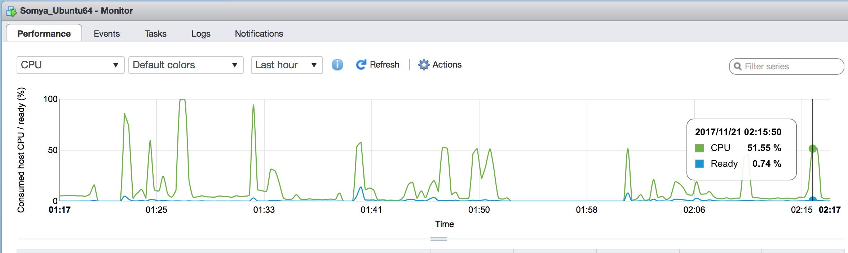

## Appendix 11: CPU Utilization and execution time for configuration 5 with optimized code

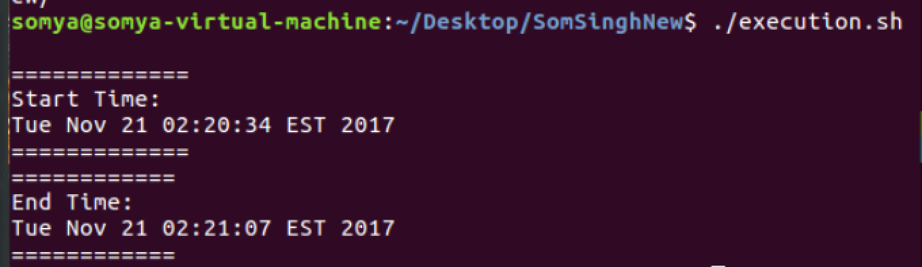





## Appendix 12: Execution time for configuration 6 with optimized code

VM 1: Response time increased to 55 secs

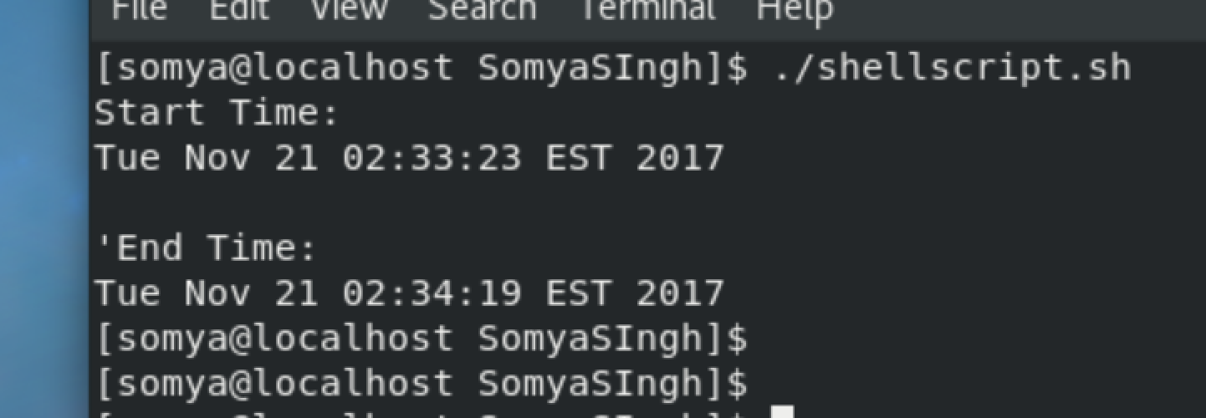

VM2: Response time increased to 57 secs

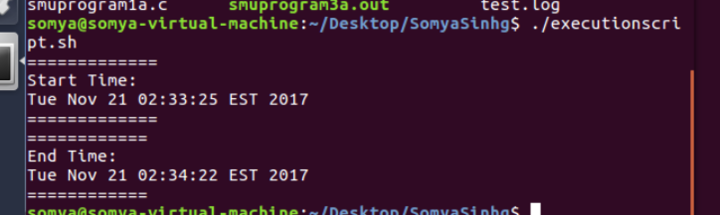

## Appendix 13: CPU utilization for configuration 6



## Appendix 14: Execution time for configuration 7 with optimized code and configuration 6

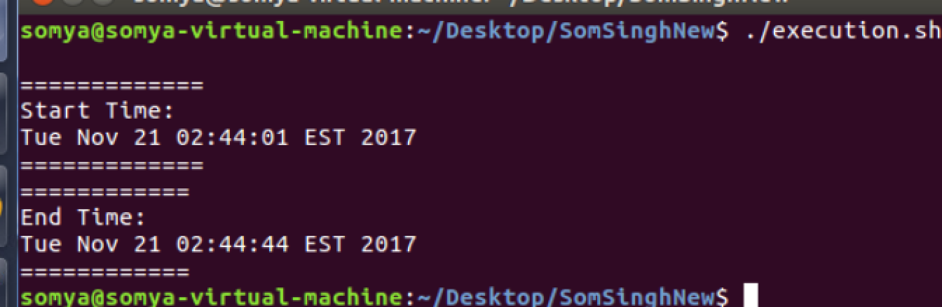

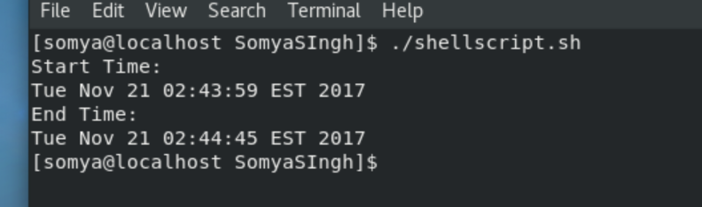

## Appendix 15: CPU utilization for configuration 7 with optimized code and configuration 6

